Topic 1. History of Application Modeling
Introduction

In this topic we will discuss the importance of application modeling, for example, a programmer who must develop a program and does not know how to do it, with the help of support resources or courses on the subject is faster and easier development. The same happens in a software development team, by means of the diagrams they can easily locate each other to solve problems with the system and communicate in a proper way, so that everyone involved knows what they must do.

Programmers often must master a complex project in a very short period of time, for which there are UML(Unified Modeling Language)-based design techniques that help to achieve a complete view of the system. With a glance at a class diagram, you can quickly identify the types of abstractions and the parts that will require the most work. An interaction diagram shows the key behaviors of the system.
Explanation

1.1 Evolution of application modeling
Modeling reduces the complexity of the problem under study and allows us to focus on one aspect at a time. This is the "divide and conquer" approach proposed by Dijkstra, which is based on the premise that if we divide a difficult problem into a series of smaller subproblems, they can be solved more easily. A suitable model allows modelers to work at higher levels of abstraction. The use of modeling is based on four basic principles.
Click on each item for detailed information
Principle 1
The choice of which models to create has a profound influence on how a problem is approached and how a solution is shaped (choose the appropriate and necessary methods according to the need or desired objective).
Principle 2
Any model can be expressed with different levels of accuracy (it can be modeled with as much detail as necessary).
Principle 3
The best models are linked to reality (models should be attached to real world elements).
Principle 4
A single model or view is not enough. Any complex system is best addressed through a small set of independent models, with multiple points of view (as different people from different areas are involved, it is good to have a model in each one to address the common language of each sector).
The initial versions of UML (UML 1) originated with three leading object-oriented methods (Booch, OMT and OOSE), and incorporated several best practices in modeling language design, object-oriented programming, and architectural description languages. Relative to UML 1, this revision of UML has been enhanced with significantly more precise definitions of its abstract syntax and semantic rules, a more modular language structure, and a greatly improved ability to model large-scale systems.
The key to a good model is abstraction, capturing the important aspects and ignoring ambiguities. Some features that models should include are:
- Micro-models: referring to the size and magnitude of the model of a system, 10 to 20 lines may be sufficient to express a system comprising thousands of lines of code. The idea is to generate a language that is small and easy to use, yet powerful and flexible for complex systems.
- Analyzable: the purpose of the models is to obtain simulations of the final application and analyze its behavior, through structures and behaviors.
- Declarative: models must describe the state and behavior of the system, as well as its properties and constraints.
- Structural: the models must have a sequence of events.
1.2 Scope of application modeling
One of the main goals of UML is to advance the state of the industry by enabling visual object modeling tool interoperability. However, to enable meaningful exchange of model information between tools, agreement on semantics and syntax is required. UML meets the following requirements:
- A formal definition of a common MOF-based metamodel that specifies the abstract syntax of UML. The abstract syntax defines the set of UML modeling concepts, their attributes and their relationships, as well as the rules for combining these concepts to build partial or complete UML models.
- A detailed explanation of the semantics of each UML modeling concept. Semantics defines, in a technology-independent manner, how UML concepts are to be realized by computers.
A specification of the human-readable notation elements for representing individual UML modeling concepts, as well as rules for combining them into a variety of different types of diagrams corresponding to different aspects of the modeled systems.
To learn more about UML diagrams we recommend reading:

Creately. (2021). UML Diagram Types Guide: Learn About All Types of UML Diagrams with Examples. Retrieved from https://creately.com/blog/diagrams/uml-diagram-types-examples/
The following link do not belong to Tecmilenio University,
when accessing to them, you must accept their terms and conditions.
1.3 Why does software need models?
Software processes use incremental software development, that is, by iterations or cycles, as the main strategy to mitigate the risk of misidentification of requirements.
In an iteration or cycle the development team produces a visible set of new functional requirements that can be delivered and validated by the customer. In each cycle, as a basic rule, a set of functionalities to be added to the product is selected, these functionalities are frozen, meaning, they are not changed while the cycle is completed.
While the primary motivation for short iterations or cycles is to produce a product increment, it is also an opportunity to achieve an improvement in the development process and team maturity. For this reason, it is very important that, at the end of each cycle or iteration, the team should carry out a reflection or postmortem on the work done and the way it was done and propose improvements for the next cycle.
In this way, designers, programmers, marketers, documenters, among others, will be able to easily understand the magnitude of the project being developed.
Some examples where UML models are very useful are:
- Websites
- Business modeling
- Databases
- Web applications
- Electronic circuits
- Among others
In this sense, it is extremely important, since today's applications are oriented to web development, since their architecture is based on the HTTP communication protocol.
Based on the most widely used standards, in 1998, Jim Conallen defined an extension which he called WAE (Web Application Extension) for UML. WAE extensions are used for the class diagram and their relationships, some examples are:
- Server Page
- Client Page
- Form
- ClientScript Object
- Link
- Submit
- Build
- Redirect
Conclusion

In this topic, we discussed the importance of application modeling, as well as the characteristics that the models and their applications should include. Application modeling helps software development projects to be successful because it allows all collaborators to visualize the final product, as well as to better understand the system and integrate different ideas.
Finally, please review the following video that explains in a more dynamic way what a software architecture is.
Topic 2. Application Development
Introduction

Nowadays, software applications have a great impact on our daily life activities. They are the engine for the growth of businesses, government agencies and society in general. Thanks to the various software applications, it is possible to automate tasks, boost productivity, obtain key information, improve people's communication, among many other functions that make them a fundamental part of the economy and the world.
In addition, thanks to their lifecycle, we will be able to detect errors as early as possible, allowing us to focus on software quality, implementation time and associated costs.
Explanation

2.1. Application life cycle
What is meant by the life cycle of a project?
The life cycle of a project can be defined as:
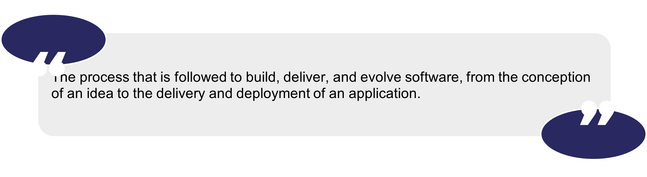
Some software life cycles are as follows:
Cascading life cycle: it consists of sequential phases, where the completion of one phase implies the beginning of the next one. Next, we will review what each phase consists of:
- Analysis: the client's needs and the end users of the application to be developed are analyzed to determine the requirements.
- Design: the application to be developed is architect and designed based on the requirements identified in the previous phase.
- Implementation: this phase starts with the development of the application code.
- Testing: its purpose is to ensure that the application is implemented correctly and complies with the specifications.
- Maintenance: phase dedicated to the deployment and support of applications.
Spiral life cycle: it is based on iterations where each one of them contains a set of activities that must be carried depending on what is determined in each one of them. Some of these interactions may be:
- Objective
- Risk analysis
- Develop and approve the application
- Planning
Iterative and incremental life cycle: it involves the execution of a set of activities in parallel and delivers value in each of the iterations, allowing feedback and early involvement among all stakeholders in the project, reducing some of the common problems in software development.
The planning of this type of project is divided into iterations instead of domains, and tasks are performed in each of these iterations and involve different areas and, in the end, allow to show part of the functionality to the users and, based on their comments, to plan the next iteration.
V-Life Cycle: it is focused on the review and testing of each stage of the project. Each stage has another stage where, based on verification and validation activities, it is ensured that the application was built correctly and meets the client's expectations.
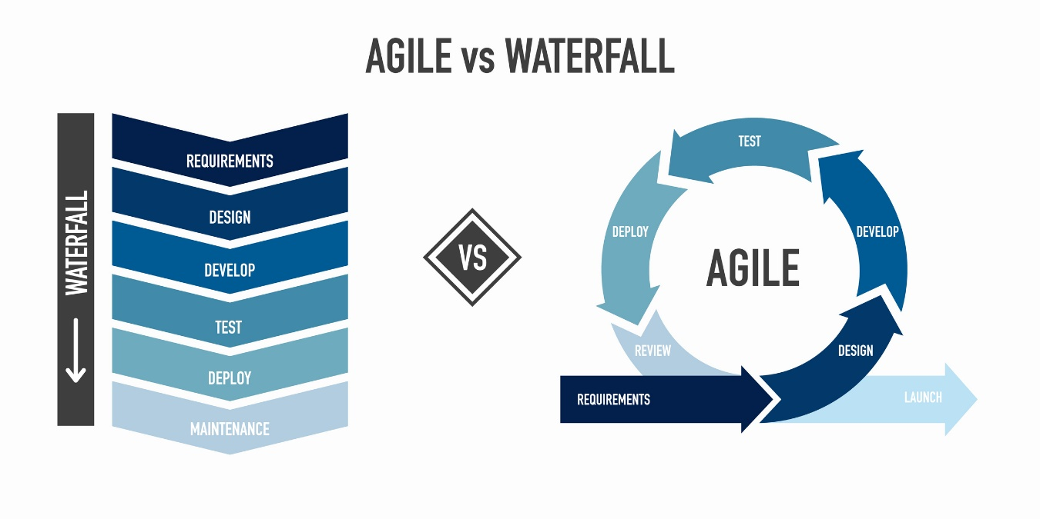
2.2 Phases in the unified software development process
This specification defines the Unified Modeling Language (UML), the objective of UML is to provide system architects, software engineers and software developers with tools for the analysis, design and implementation of software-based systems, as well as for modeling business and similar processes. Every model requires an order to achieve customer requirements. In the case of the unified software development process, we will review some of the phases involved in this process:
- Planning: This phase will serve to organize the project.
- Analysis: once we have defined, in a general way, our project, we must ask ourselves, what does our application do or what does it need to do? During the analysis, the elements should include logical concepts of the problem and the real world.
- Design: Now we will specify how the application will work. Elements of the design and architectural solution will be included during this phase.
- Implementation: here we will create the application.
- Testing: during this phase we will make sure that the application works correctly.
- Deployment: after validating that everything works correctly, we install and configure the final application on the servers and on the users' computers.
The phases of the unified software development process are built in a language known as UML, which has semantics (texts) and notation (graphics). Let us start with the semantic aspect (texts), which must be used in the phases of the unified software development process:
- The first thing we must do is to grasp the meaning of the application as a network of logical constructs, i.e., classes, states, use cases and messages.
- Then you must carry the meaning of the model.
- All the above is used for code generation, validity checking and complexity metrics.
- The syntactic structure, rules for its correctness and dynamics of execution must be always taken care of.
In addition to the semantics, we must consider the notation (graphics), which is the graphical material seen in the models; it shows the semantic information in a way that can be understood by all those involved.
Considering the previous paragraph, we can use views, which are a projection of a model seen from a certain perspective or observation point, referring to the projections of the semantic model and the visual notation. There are different views:
- Structural classification
- Dynamic behavior
- Model management
What is UML?
As we have already discussed, one of the main objectives of UML is to advance the state of the industry by enabling visual object modeling tool interoperability. However, to enable meaningful exchange of model information between tools, agreement on semantics and syntax is required, plus it performs the following tasks:
- Specification
- Display
- Architectural design
- Construction
- Simulation and testing
- Documentation
The purpose of using a unified software development process is to capture and list, exhaustively, the requirements and domain knowledge, so that all members of the development team can understand it.

UML was originally developed with the idea of promoting communication and productivity among developers of object-oriented systems, but the apparent power of UML has led it to make inroads into all types of systems and software development.
UML modeling also supports multiple views of the same system. This is how you can have a political map, a relief map, a road map, and a utility map of the same area to use for different purposes or different types of architectural diagrams and plans to emphasize different aspects of what is being built. You can have many different types of UML diagrams, each of which is a different view showing different aspects of your system.
Different types of diagrams with their respective cases are shown below:
- Structural Diagrams
Click on each item for detailed information
Class diagram
They are used to show real-world entities, analysis and design elements or implementation classes and their relationships.
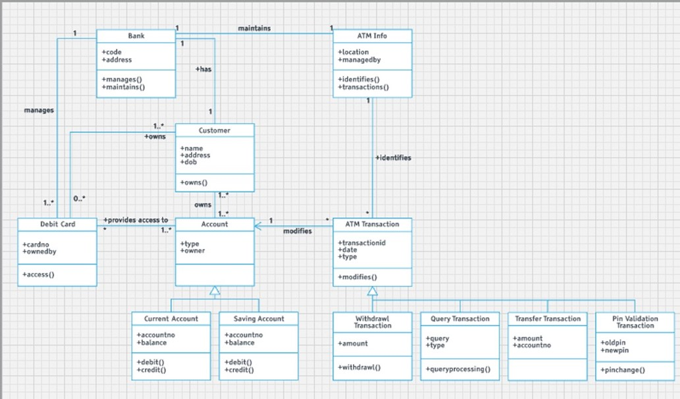
Figure 2. Example of a class diagram in Lucidchart.
Source: This screen was obtained directly from the software being explained on the computer, for educational purposes.
Object diagram
They serve to show a specific or illustrative example of objects and their links. It is often used to indicate the conditions of an event, such as a test or an operation call.
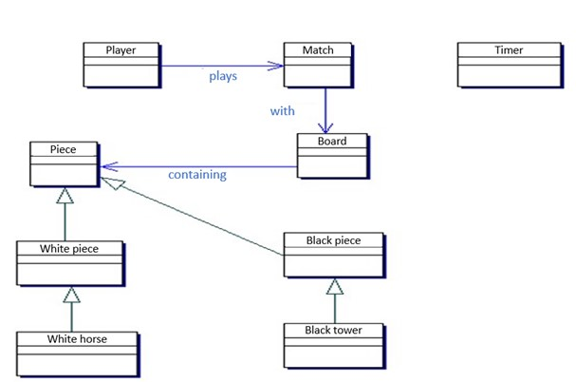
Figure 3. Example of object diagram in StarUML.
Composite structure diagram
To show how something is done. Especially useful in complex structures of structures or in component-based design.
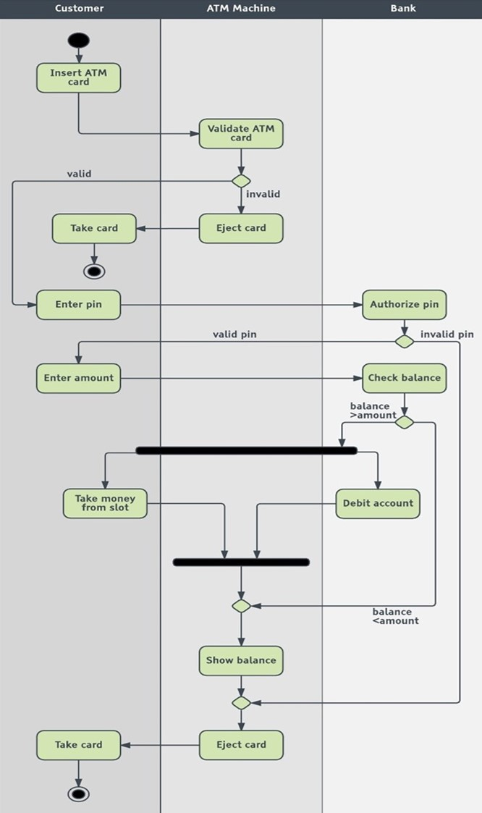
Figure 4. Example of a composite structure diagram in Lucidchart.
- Interaction diagrams
Click on each diagram for more information.
General diagram
It serves to show many different interaction scenarios (a set of elements working together to achieve a goal).
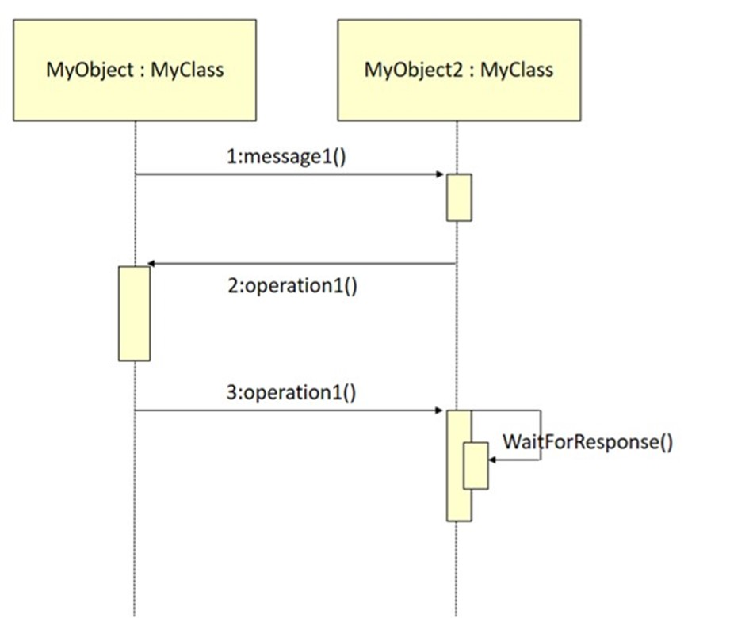
Figure 11. Example of general diagram (interaction) in StarUML.
Sequence diagram
It focuses on the exchange of messages between a group of objects and the order of the messages.
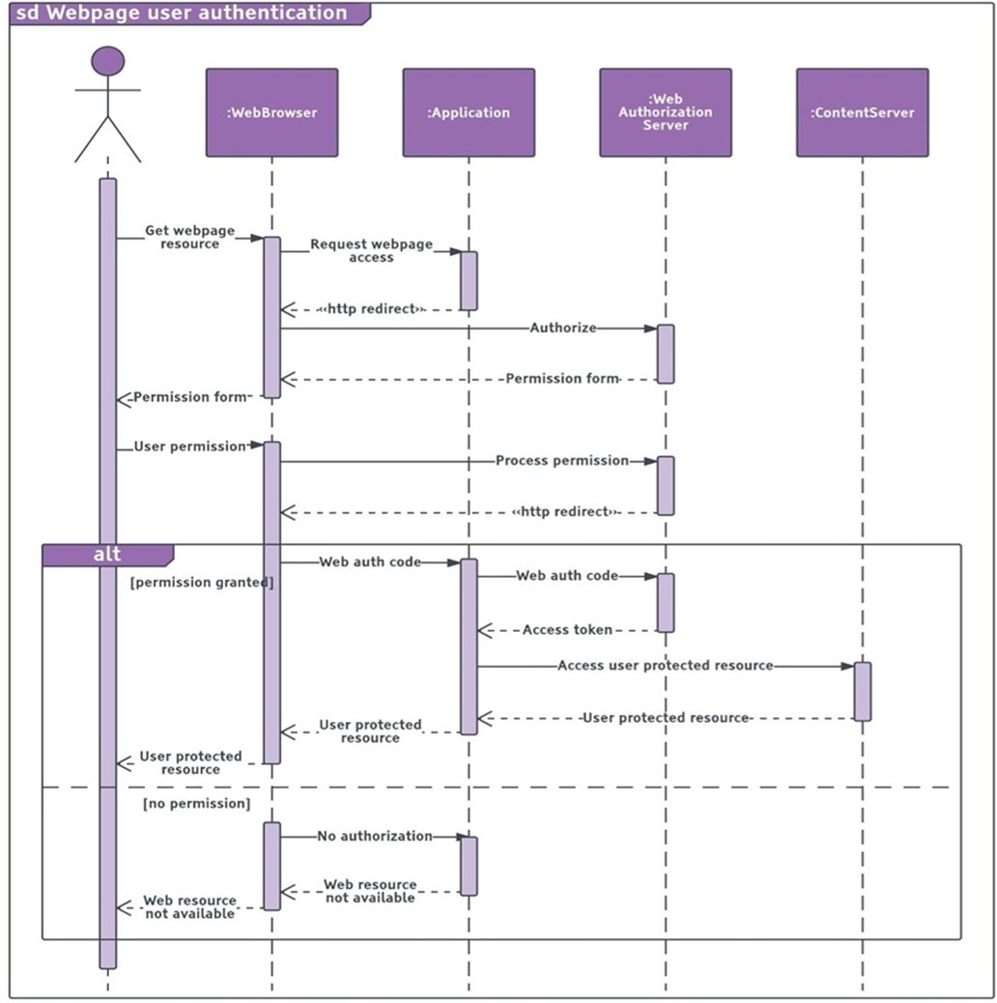
Figure 12. Example of sequence diagram in Lucidchart.
Communication diagram
It focuses on the messages between a group of objects and the underlying relationship of the objects.
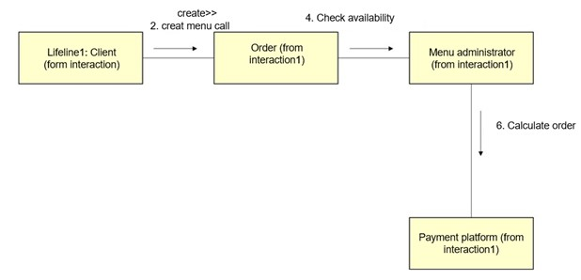
Figure 13. Example of communication diagram in StarUML.

2.3 Recommendations for application modeling
Some recommendations on application modeling which are included in OMG (2017) are as follows:
- Component creation: Speaking of best practices, let us start by writing software units as groups of cooperating objects that can be reused from application to application.
- Separation of components: another recommendation is to identify the functionalities of the components, that is, to separate what the component can do from how it does it. The idea is to replace one component with another.
- Communication between components: finally, to replace components, we must standardize the exact way in which they communicate.
Conclusion

In this topic we learned that there are several types of life cycle, which describe the phases through which the development of a software application goes through.
Each of these life cycles has advantages and disadvantages. The nature of the project, the work team and the relationship with the client are some of the factors that must be considered when selecting a life cycle for the execution of a software application development project.
The concepts learned so far are crucial for the development of software applications.
Topic 3. Concept of the Object-Oriented Paradigm
Introduction

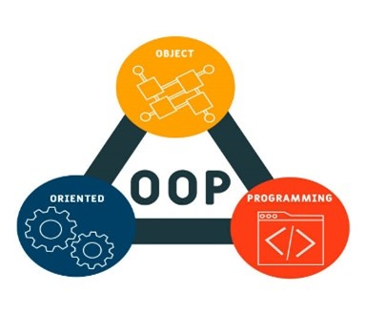
A paradigm is a new way of approaching reality. Object-oriented programming is a new paradigm that allows programming in a more effective way, allows the creation of simulations and prototypes of the real world and is easy to encapsulate; for this reason, it has been very successful and is increasingly used in today's world. These have many advantages such as, ease of adding objects that allow us to make simple modifications, extensive documentation, design benefits, rapid development, and also high code quality, you will learn more about the paradigms in this topic.
Explanation

3.1 Key concepts
Object-oriented technologies became, in the 1990s, one of the key drivers of the software industry. They have their origins in Simula 67, an object-oriented language, developed in 1967. The object orientation paradigm is a different approach to the computer world, involving the creation of models of the real world and the construction of programs based on those models. The entire programming process begins with the construction of a model of the actual event. The result of the process is a computer program containing features that represent some of the real-world objects that are part of the event.
Some of the causes that are considerably influencing the remarkable development of object-oriented techniques are:
- Object orientation is particularly suitable for certain applications, especially prototyping and program simulation.
- Encapsulation supports a high degree of code reuse, which is increased by its inheritance mechanisms.
- In the database environment, Object Orientation is well attached to semantic data models, to solve the limitations of traditional models.
- Growth of object-oriented programming languages.
Graphical (icon-based) and visual user interfaces. An application's user interfaces manipulate user input and output. Therefore, their main function is communication with the end user.
Most of today's languages, operating systems and tools are object-oriented, which gives more reasons to see the world from this concept.
Below are some object orientation paradigm concepts:
- Class
What is a class?
A class is a family of objects that share the same characteristics (attributes, operations, relationships and semantics) and are the most important building blocks of any object-oriented system. Classes are used to capture the developing system's vocabulary and may include abstractions that are part of the problem domain. The classes must have a unique name that identifies them amongst each other.
What is an object?
When running an object-oriented software system, the elements of the system interact with software objects, these must be parallel to the company's business objects (real tangible things that represent the software objects).
Objects are something usually drawn from the vocabulary of the problem space or solution space. Every object has an identity (it can be named or otherwise distinguished from other objects), state (there are usually some associated with it) and behavior (things can be done to the object and it in turn can do things to other objects). The elements of an object are:
- Identity
- Structure
- Behavior
Objects are represented in the same way as classes, with the difference that their names are underlined to differentiate them and followed by the name of the class, separating the two names by a colon:
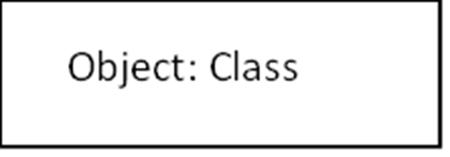
- Attributes
What is an attribute?
The data type of an attribute can be primitive or user defined. Using the words of rcasalla (2021), the standard UML primitive types are as follows:
- Boolean,
- Integer,
- UnlimitedNatural,
- String,
- Real.
- A good practice, when defining attributes, is to identify fixed lists, which are usually limited possible values, better known as enumeration data. Example: gender, state, country, among others.
- Remember that attributes with default values can also be defined. Sometimes an attribute can have more than one value, for example, two phone numbers or two names; in these cases, UML allows you to save a range of options through multiplicity, these should be placed in square brackets [multiplicity] after the attribute type.

- Nomenclature of an attribute:
Attribute_name: Type [Multiplicity]

UML | Multiplicity
1 | Default value
2 | Exactly two values
1..3 | From 1 to 3
3,5 | 3 or 5
1..* | Minimum one value and maximum unlimited values
0..1 | 0 or 1

- Operations
What is an operation?
The argument of an operation specifies a piece of information needed by the object to perform this operation. It is necessary to specify the information required for the operation in an optional argument, argument list or comma-separated parameters. The specific things that the object needs to perform this operation, as well as the arguments, go together:
Option_name: (argument1, argument2, ...): Result
Tip: Since more than one person can have the same name, it is suggested that operations take the name of the class to which they belong according to precedent.
- Responsibilities
What is a responsibility?
It is a contract or an obligation of a kind. At an abstract level, the attributes and operations of a class are the characteristics by means of which its responsibilities are carried out. A class can have any number of responsibilities.
Type of noun | Example | Element
A family of things | Person | Class
A proper name | Juan | Object
A property of something | Age, height, weight | Attributes
A value or date | 18 years old, 1.60 m., 60 kg. | Attribute values
A condition of a thing | Adult, married | State
An occurrence, event, or time | Birthday, phone | Operation
Part of the implementation | Database, table | Part of the design

3.2 Properties of the object-oriented paradigm
The properties of object orientation are certain premises or special characteristics, which are seen as the advantages or benefits of the object-oriented paradigm. Below are each of them.
Click on each item for detailed information
Encapsulation
It is the property that objects have, of hiding the internal functionality of their operations from other objects and the outside world; for example, an object of the computer class does not show its internal processes to perform its operations; simply by performing one of its operations we can observe the result without the need to see or know all the steps that the computer had to perform to get to it.
Modularity
Modularity is the property that allows you to subdivide an application into smaller parts (called modules), each of which should be as independent as possible from the application itself and the other parts.
Polymorphism
A feature that allows an operation to have the same name in different classes, but its function is different in each one; that is, in object orientation, each class knows what it must do independently, even if an operation has the same name and is contained in several classes. For example, the “Open" operation can be contained in the Door, Bank Account, Elevator classes, but when calling the class in question, the operation to be performed will be the one defined in that class.
Abstraction
It refers to removing the properties and actions of an object to leave only those that are necessary for the representation, design and implementation of what is required; that is, a representation of the real world has many features and maybe not all of them necessary to consider. Which is why it is said that an abstraction of the element is made and only those properties that serve our purpose are considered.
Inheritance
Objects inherit the properties and behavior of all classes to which they belong. Inheritance organizes and facilitates polymorphism and encapsulation, allowing objects to be defined and created as specialized types of pre-existing objects. These can share (and extend) your behavior without having to re-implement it. One class (the secondary class or subclass) can inherit the attributes and operations of another class (main class or superclass); when an object inherits properties from more than one class, it is said that there is a multiple inheritance. For example, the superclass Animal inherits its attributes and operations to subclasses Amphibian, Mammal and Reptile, since these classifications correspond to a more general one. It can be seen in the picture that the Horse class is a subclass of Mammal, so it inherits the attributes of Mammal and in turn those of Animal.
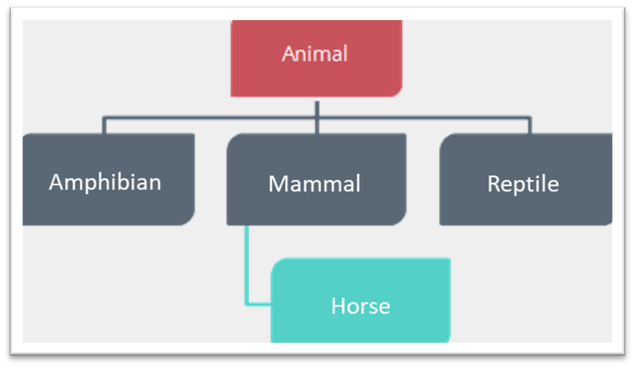
Aggregation
Sometimes a class consists of other classes. The components and the class they constitute are an association that forms a whole. For example, the Computer Equipment class is made up of the subclasses Speaker, Cabinet, Keyboard, Monitor, Mouse and Video Card.
Association
The fact that classes are conceptually connected to each other is known as association. That is, classes participate with each other or are related in some way to each other; for example: considering that there is Player class and the Team class, the Player class is associated with the Team class, since a player participates in a team. It could be said in the same way that a team employs players, so the Team class is associated with the Player class. Associations can be in one or more directions.

3.3 Fundamentals of modeling
There are many methods to select, in an appropriate way, the objects and classes; one is to underline the nouns and the words that are related to them; this exercise allows you to identify the classes and objects respectively. Subsequently, we start describing the behavior of the system, then we check if the objects and classes meet the following criteria:
- It is a thing or a family of things.
- It is part of a problem that needs to be solved.
- It is not part of the implementation details.
- It is not an event or occurrence.
- It is not a property of something.
If you have doubts about a noun, add it to the list and try to include it in a class, that way you can rule out if the object is an instance of some class. All those nouns that you discard as objects or classes, can later serve as attributes, states, operations, events, among others.
Object nomenclature
Once the classes and objects have been identified, we will name them taking some UML rules (Chonoles and Schardt, 2011) into account:
- Use a noun or noun phrase.
- In singular.
- Avoid adjectives.
- Use capital letters at the beginning.
- Avoid spaces between words.
- Do not use articles.
- The name should convey information quickly and accurately.
- Avoid abbreviations and acronyms.
- Check spelling and grammar.
- Visibility
As noted by rcasalla (2021), visibility defines whether the properties of classes (meaning, attributes and methods) can be seen or used by other classes. The visibility levels are public, private or protected, which are represented by the +, -, # icons, respectively. In the example, age is a private attribute. Moreover, a private property can be viewed and used only by the class that contains it. A public property can be viewed and used by the class that contains it and by any other class. A protected property can be viewed and used only by the class that contains it and by its subclasses.

Conclusion

Currently, the object-oriented approach is part of the main trend for software application development, since it has proven to be valid in the construction of systems in all kinds of problem domains, covering the whole range of sizes and complexities.
This topic explained the origins, benefits and basic concepts of the object-oriented paradigm. The concepts learned so far are crucial for the development of computer systems. Understanding them will facilitate the modeling of software applications. In closing.
Topic 4. Unified Modeling Language
Introduction

Nowadays, application modeling is a fundamental part of software development: but what is the most used method? What notations are used? What is UML's role?
But why do we model, basically we build models to understand and have a better visualization of the system we are programming.
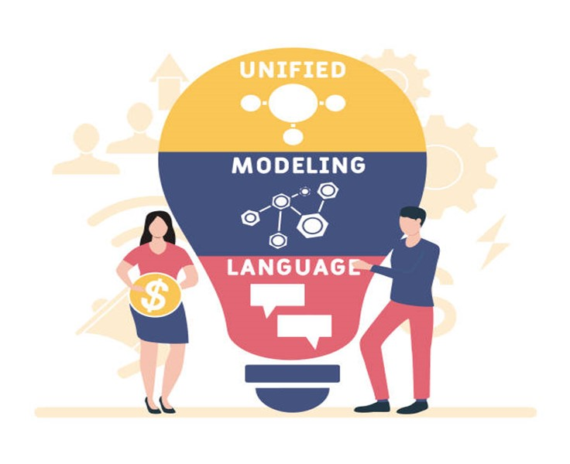
In this topic you will understand what the UML is, what its elements are and how they relate to unified modeling, its rules, mechanisms, and relationships.
Explanation

Explanation
4.1 Basic UML blocks
The Unified Modeling Language (UML) is a standard language for writing software blueprints. It is suitable for modeling everything from enterprise information systems to distributed web-based applications, and even for very demanding real-time embedded systems. Moreover, it is an expressive language that covers all the necessary views for developing and, later, deploying such systems.
UML is just a language and, therefore, is only a part of a software development method. It provides a vocabulary and the rules for combining words from that vocabulary to enable communication.
UML is a language for:
- Visualization: more than a simple set of graphic symbols, there is in its notation, a well-defined semantics that allows to communicate in a graphic or textual way the same meaning.
- Specification: it means building accurate, complete and unambiguous models, covering the specification of all analysis, design and implementation decisions that must be made when developing and deploying a software-intensive system.
- Building: means that it is possible to establish correspondences from a UML model to object-oriented programming languages, and even to tables in a database.
- Documentation: covers the documentation of a system's architecture and all its details, as well as providing a language for expressing requirements and tests, and project planning and version management activities.
UML can be used in the following domains:
- Business information systems
- Banks and financial services
- Telecom
- Transport
- Defense/aerospace industry
- Trading
- Electronic
- Medical
- Scientific field
- Web-based distributed services
UML is not limited to software modeling, it can also be used to design hardware, workflows of any type of process and other areas of interest. The UML vocabulary includes three classes of basic building blocks:

Elements are abstractions that constitute the first-class citizens in a model. There are four types of elements. Each of them is discussed.
1. Structural elements
They are the names of UML models that, for the most part, are the static parts of a model and represent concepts or material things. They are referred to as classifiers collectively. Below are the structural elements.
Structural elements
Click on each item for detailed information
Class
It is a description of a set of objects that share the same attributes, operations, relationships and semantics.
Interface
It is a collection of operations that specify a service of a class or component (represents the external visible behavior of that element).
Collaboration
It defines an interaction and is a society of roles and other elements that collaborate to provide cooperative behavior greater than the sum of its elements' behaviors.
Use case
It is a description of a set of sequences of actions that a system executes and that produces an observable result of interest to a main actor. It is used to structure the behavioral aspects in a model.
Component
It is a modular part of the system design that hides its implementation behind a set of external interfaces.
Artifact
It is a physical and replaceable part of a system that contains physical information. In a system there are different types of deployment artifacts such as source code files, executables and scripts.
Node
It is a physical element that exists at runtime and represents a computational resource.
2. Behavioral elements
They are the dynamic parts of UML models. They are also considered as the verbs of a model and represent behavior in time and space. The behavioral elements are described below.
Behavioral elements
Click on each item for detailed information
Interaction
It is a behavior that comprises a set of messages exchanged between a set of objects within a particular context, in order to achieve a specific purpose.
State machines
It is a behavior that specifies the sequences of states through which an object or interaction passes during its lifetime, in response to events along with its reactions to these events.
Activities
Specifies the sequence of steps that a computational process executes, emphasizing the flows between steps or actions.

3. Grouping elements
They are the organizational parts of UML models. These are the boxes in which a model can be decomposed. The following is a description of grouping elements:
Grouping elements
Click on each item for detailed information
Package
A general-purpose mechanism for organizing one's own design conceptually. All items can be grouped within packages.

4. Annotation elements
They are the explanatory parts of the UML models. They are comments that can be applied to describe, clarify and make observations about any element of a model. The following describes the annotation elements:
Annotation elements
Click on each item for detailed information
Note
A symbol for displaying constraints and comments next to an item or a collection of items.

4.2 UML relationships
The relationships that exist in a class diagram allow defining the dependencies between classes if a class is necessary for the implementation of another one. The four different relationships that can be implemented in a class diagram are discussed below.
Relationships
Click on each item for detailed information
Dependency
A semantic relationship between two elements, in which a change to one element (independent) can affect the semantics of the other element (dependent).
Association
Structural relationship between classes that describes a set of links, which are connections between objects that are instances of classes.
Generalization
It is a specialization relationship in which the specialized (child) element is based on the specification of the generalized (parent) element.
Realization
It is a semantic relationship between classifiers, where one classifier specifies a contract that another classifier guarantees that it will fulfill.
4.3 UML diagrams
UML rules
UML building blocks cannot be combined in any way, because UML has certain rules that specify how a well-formed model should be; that is, semantically self-consistent and in harmony with all its related elements.
UML has syntactic and semantic rules for:
- Names: how to call elements, relationships and diagrams.
- Scope: The context that gives a specific meaning to a name.
- Visibility: how those names can be seen and used by others.
- Integrity: how elements are properly and consistently related to each other.
- Execution: What it means to execute or simulate a dynamic model.
Common mechanisms
UML is simplified by the presence of four common mechanisms that are consistently applied throughout the language:
Common mechanisms
Click on each item for detailed information
Specification
It is used to express the details of the system and provide a semantic basis that includes all parts of the system models, each part being related to the others in a consistent way.
Adornments
Details added to the graphic notations of diagrams or elements, to specify characteristics or highlight data types.
Common divisions
Representative differences between related elements that differentiate them from each other (object/class, interface/implementation and type/role).
Extensibility mechanisms
A characteristic of UML that describes it as open-closed, with the possibility of extending the language in a controlled way in stereotypes (extension of the UML vocabulary allowing to create new types of building blocks), tagged values (extends the properties of a UML stereotype, allowing to add new information in the specification of that stereotype) and a constraint (extends the semantics of a UML building block, allowing for the addition of new rules or for the modification of existing ones).

Conclusion

UML is process-independent, therefore it is not tied to any software development life cycle; however, to get the most benefit, a process that is use-case driven, architecture-centric, iterative and incremental should be considered.
In this topic the elements that make up the main structure of UML and addressed the notations, diagrams, rules and other mechanisms that the model handles were reviewed. Now you have the basics to build diagrams, using UML notation.
Topic 5. CASE Tools for Application Modeling
Introduction

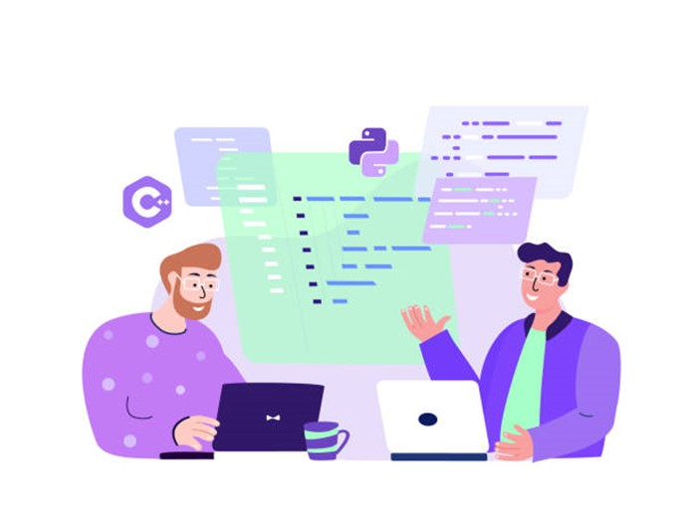This topic deals with CASE tools, a tool used for software development, specifically in the modeling of objects. You will learn about the history of its creation and evolution, as well as its structure and integration elements. In addition to this information, some examples of CASE tools are shown, both on the website and in software, so that you can identify which one suits you best. And so, have a more complete and easier to develop diagram.
Explanation

5.1 CASE tool components
Today, there are tools that help us automate tasks, facilitate the construction of modeling and code in order to make application development more efficient. The so-called CASE (Computer Aided Software Engineering) technology is defined as "the set of tools and methodologies that support an engineering approach for the different phases of software development".
These are some of the advantages of using a CASE tool as part of the activities in a software development project:
- Streamline work by automating tasks.
- Facilitate prototyping and joint application development.
- Simplify program maintenance.
- Improve and standardize documentation such as models and code.
- Increase the portability of applications.
- Facilitate the reuse of design components and code.
- Enable visual development and refinement of applications through graphic use.
In a schematic way, we can say that a CASE tool consists of the following elements:
Click on each item for detailed information
Repository (dictionary)
Where elements defined or created by the tool are stored and whose management is done with the support of a Database Management System (DBMS). The repository extends the concept of data dictionary to include all information that is generated throughout the system's life cycle, such as analysis and design components, program structures, algorithms, among others. Most CASE tools either have their own repository or work on a repository provided by another vendor.
Metamodel (not always visible)
Constitutes the framework for the definition of the techniques and methodologies supported by the tool.
Data uploading or downloading
These are facilities that make it possible to load the CASE tool's repertoire with data from other systems, or to generate, from the tool itself, database schema, programs, among others., which can, in turn, feed other systems. Thus, this element provides, a means of communication with other tools.
Error checking
Facilities to perform an analysis of the accuracy, completeness and consistency of the schema generated by the tool.
User interface
It will consist of text editors and graphic design tools that allow, using a system of windows, icons and menus, to define the diagrams, matrices, among others., included in the different methodologies.
CASE tools not only exist in isolation or are run independently, but there may be integrations between some of them, as long as they are compatible. CASE tools can be integrated into three types:
- Data integration: which establishes the possibility for a tool to use or deliver information to other tools, either through a data transfer mechanism or through a repository.
- Control integration: a situation in which one tool can invoke others and communicate events to them.
- Presentation integration: which refers to the homogeneity and consistency of the user interface; for example, that all tools access help in the same way, thus avoiding surprises for the user.
5.2 Fields of application of CASE tools
The field of application of CASE tools is the development of software applications, not specifically in some phase or discipline, but rather in the life cycle of a project. There are several types of CASE tools specialized in certain functions, so most of the activities of a project can be carried out using one of them, which can be classified considering the following parameters:
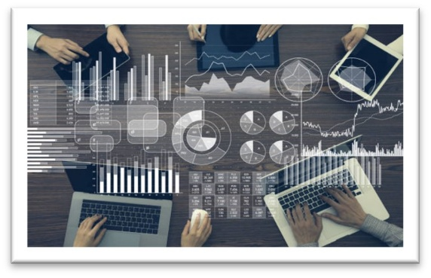
- The levels of the project in which they are used.
- The phases of the system development life cycle that they cover.
- Their functionality.
- Mastery of the problems they solve.
- Their functionality.
The following describes the fields of application or uses that can be given to CASE tools, as part of the activities for the development of a software project for each of its classifications.
CASE tools classified by levels
There are three types:
- High-level CASE: they allow to automate the activities of the final or higher phases of the application development life cycle for everything related to system planning, analysis and design.
- Low-level CASE: they support the lower parts of the lifecycle, such as detailed design, implementation and application support.
- Cross life-cycle CASE: used to perform activities that take place throughout the entire life cycle, such as project management and estimation.
CASE tools classified by life cycle phases
- Upper CASE (U-CASE): they help in the planning, requirements analysis and strategy phases of development using, among others, UML diagrams.
- Middle CASE (M-CASE): they automate tasks in the (detailed) analysis and design of the application.
- Lower CASE (L-CASE): they semi-automate code generation, create error detection programs, support program debugging and testing. In addition, they automate the complete documentation of the application. Rapid application development tools can be included here.
CASE tools sorted by functionality
- Semi-automatic code generation tools: they allow semi-automatic code generation based on previous modeling.
- UML Editors: they facilitate the modeling of UML diagrams and notation.
- Code refactoring tools: they allow to improve the quality of the code.
- Maintenance tools such as version control systems: they are used for the following:

  - Version control: they allow to store and give controlled access to data, as well as to register changes to data and recover previous versions.
  - Make: automates the tasks associated with compiling and linking a system to generate executables.
  - Requirements traceability and impact analysis: these allow, respectively, to trace a requirement to its implementation and to know which system elements are affected by a change.
CASE tools classified by problem domain
- Analysis and design tools: they are used to create and modify E/R diagrams, data flow diagrams, table structure diagrams, class diagrams, and so on. They are also used as prototyping tools to design screens, generate menus and reports and other executables.
- Code generation and documentation: they are used to generate code from the design specifications, both for programs (for example, in C or COBOL), and convenient database schemas (definition statements in SQL). They also support the automated creation of a very varied set of documentation (obtained from the information stored in the directory), ranging from the textual description of a pseudocode to complex diagrams.
- Testing tools: also known by the acronym CAST (Computer Aided Software Testing), they are used to define test requirements and objectives, design them, prepare environments, execution of the tests and reports of results.
Reverse engineering tools
Their field of use applies to four types of activities:
- Reverse engineering of processes: they allow to isolate the logic of entities and business rules from the code.
- Source code restructuring: they modify their format or implement a standard format.
- Re-documentation: they allow to generate diagrams, so that the code is better understood.
- Code analysis: its functionalities range from the automatic indentation of the source code to the possibility of dynamically displaying its calls.
Some points to consider for the implementation of a CASE tool are described below:
- Identifying the need for what needs to be done or the problem that arises.
- Identifying the strategic level that the systems should have.
- Evaluating the available hardware and software resources and the medium.
- Evaluating the staff.
- Carrying out a cost-benefit study defining the goals to be achieved.
- Choosing the appropriate tools.
- Establishing a training program on the tools.
- Choosing an application that meets most of the following requirements:

  - High impact of results.
  - Availability of resources.
  - Minimum level of risks.
  - Maximum user collaboration.
  - Reduced solution size.

- Establishing compatibility interfaces of the new systems that must coexist with the previous ones (if any).
5.3 Useful websites and tools for modeling
Some highly recommended application modeling websites that contain CASE tools are the following:
- UML Home Page
From this site you can find indications for the official UML 2 and UML 1 specifications. The official request for proposal (RFP) documents for UML 2 are also available. This site has additional useful background information on UML and some pointers to other informative UML.
- UML Forum
It is a virtual community and a knowledge portal that contains indications on some official information.
It contains a set of UML tutorials written by key UML developers, such as Cris Kobryn, Gunnar, Bran Selic, Morgan Björkander and J.Warmer. You will also find suggestions for tool providers, UML books and conferences.
- OCL Center
OCL is an important part of UML, whose use is increasing with the growth of Model-Driven Architecture and model-consistent business rules. You will also need to understand OCL if you want to understand the formal specifications of UML 2. This website keeps you posted on the status of OCL, OCL 2.0 and various tools dedicated to OCL.
- Argo/UML
It is a rapidly growing and improving tool, with support for OCL and automated design wizards. If you choose Argo/UML, you can access the open-source code and its community at any time.
- Cittera
It uses a web-based repository for its models and will host your models. Its collaborative development approach allows users, from all over the Internet, to work on the same model, complete with auditing and version control. Choose Cittera if your development is distributed, mobile and flexible.
- Objeteering
Each tool has its own strengths. Objeteering is strong in many areas, but it is probably the most powerful UML tool for building profiles. This means that, if you want to use one of the UML dialects, such as SPEM (Software Process Engineering Modeling, CWM (Common Warehouse Modeling) or EDOC (Enterprise Distributed Object Computing), you can use Objecteering. This tool is also useful if you want to make modifications to support your special methodology.
Conclusion

CASE tools were reviewed in this topic and now you know the types of tools there are and have the basis for selecting the one better suited for the nature of the problem to be solved.
CASE tools are of great help for the modeling of applications, since they allow the reuse of elements and, in addition, some of them are prepared to perform reverse and direct engineering. Finally, we recommend that you review the following video.

